**Title:** Assessing correlation between individual stem volume and log volumes using field-based log scaling data from eucalypt plantations.

**Authors:** André Gracioso Peres da Silva, Eric Bastos Görgens, Danitiele Cristina França Laranja, Humberto Menechelli Filho, John Paul McTague, Luiz Carlos Estraviz Rodriguez.

Abstract: The main objective was to assess which log section along the stem of *Eucalyptus* sp. trees would be most representative of individual stem volume. The dataset was composed by 6130 log scaled trees, sampled from even-aged eucalypt plantations in Brazil, where diameter measurements were directly taken along the stem at every 1.2 meters. The Smalian formula was used to calculate the volume of each log, and the Pearson’s correlation statistic (*ρ*) was used to assess the linear relationship between individual stem volume and log volumes, the latter stratified based on absolute heights. Best results were observed for logs belonging to middle canopy (between 4.8 m and 13.2 m; *ρ* > 0.99), mainly due to the more uniform geometric shape of logs.

Keywords: point cloud data, stem form factor, stand volume, forest management.

**Introduction**

The area of forest plantations around the world has expanded rapidly (e.g., from 167.5 to 277.9 million hectares in 2010-2015) contributing to supply the world’s timber and fiber needs (Pain et al., 2015). For example, eucalypt plantations in Brazil produced 87 million roundwood m³ in 2014, representing 63% of total national production (IBGE, 2014; Gonçalves et al., 2013). Despite expanding, existing areas of planted forests need to be productive and managed sustainably so to avoid unnecessary land use conversions (Pain et al., 2015).

In the context of forest management, inventory is an essential activity to comprehend the ecosystem stability (Pommerening, 2002; Binkley et al., 2002), to identify environmental services potentiality (Patenaude et al., 2005; Silva et al., 2014), to dimension timing of harvesting (Diaz-Balteiro et al., 2009; McDill et al., 2016) and to assess economic aspects of the asset (Rode et al., 2014; Zhou et al., 2013l). Among forest attributes, stand stem volume is one of most inventoried ones (Görgens et al., 2015; Silva et al., 2015). First, individual stem volumes are modeled through relationships based on attributes such as height, diameter and stem form (Ketterings et al., 2001; Lefsky and McHale, 2008; Schumacher and Hall, 1933), then, they are added up within sampled plots and the plot volumes are extrapolated to the stand level (Campos and Leite, 2013; Batista et al., 2014).

The volume models are built based on the log scaling data, which are obtained by cross sectioning the stem, measuring the dimensions of each section according to a scaling rule, and summing their volumes to obtain the individual stem volume. The scaling rule applied is dependent on the geometrical form of the stem (Cruz de León and Uranga-Valencia, 2013), being log scaling the most common and popular direct method (Moskal and Zheng, 2012). On the other hand, the direct methods have significant drawbacks such as being time consuming and dependent on cutting down the trees for data collection (Liang et al., 2014; Ketterings et al., 2001).

As alternative, the terrestrial laser scanning (TLS) technology has emerged as a promising tool to remotely assess forest attributes such as stand volume and individual stem volumes (Astrup et al., 2014; Hopkinson et al., 2004; Thies et al., 2004); it produces in an automatic fashion 3D georeferenced point clouds with high spatial resolution of the scanned scene (Liang et al., 2016). Due to this capacity of automatically generating a great amount of data, efforts have been concentrated on extracting information about the forest structure in an efficient way, extending the capabilities at fine scale assessments and filling gaps between conventional inventory techniques and airborne laser scanning (Baltsavias, 1999; Maas et al., 2008).

Current methods for plot volume calculation with TLS data rely on the classification and extraction of points belonging to the trunk, which are after modeled with geometrical fitting techniques (e.g., circle, ellipse and cylinder). Then, diameters are measured along the stem for profile derivation or 3D model reconstruction (Aschoff and Spiecker, 2004; Henning and Radtke, 2006; Lefsky and McHale, 2008; Liang et al., 2014; Tansey et al., 2009; Thies et al., 2004). A caveat is that carrying out a wall-to-wall stem recovery requires the TLS data to be obtained from multiple co-registered scans (usually three to four scans; Dassot et al., 2011) which is time consuming and more costly in relation to single-scan mode approach (Aschoff and Spiecker, 2004; Astrup et al., 2014; Cheng et al., 2007; Watt and Donoghue, 2005).

An interesting option would be to investigate which vertical section of the stem would be most representative of individual volume, so partially occluded stems could be retrieved based on such relationship. It could simplify phases of point cloud data collection and processing, inclusive, data obtained from photogrammetry and computer vision (Forsman et al., 2016; Surový et al., 2016). Moreover, we hypothesize that using a log volume as explanatory variable of individual stem volume, rather than a specific diameter, yields better modeling results because a larger portion of the stem is sampled.

As a first step, we used field-derived data from log scaled eucalypt trees belonging to even-aged plantations in Brazil (i) to investigate which log section would be the most representative of individual stem volume, and (ii) to analyze how the stem form statistic, which is the actual stem volume divided by the hypothetical cylindrical volume, varies in respect to stem size, tree age, genetic material, rotation and geographic location, and its influence in previous objective. We hypothesize that where the stem form varies within groups the results between log volume and individual volume also differs.

**Material and Methods**

The study site is located in two regions, one in northeastern Brazil, Bahia state (BA) (18º0’0’’S; 40º0’0’’W), and another in southeastern Brazil, São Paulo state (SP) (23º0’0’’S; 47º0’0’’W, Figure 1). Total area in of the study in BA is 16.6 thousand hectares, while the study area in SP is 6.4 thousand hectares.

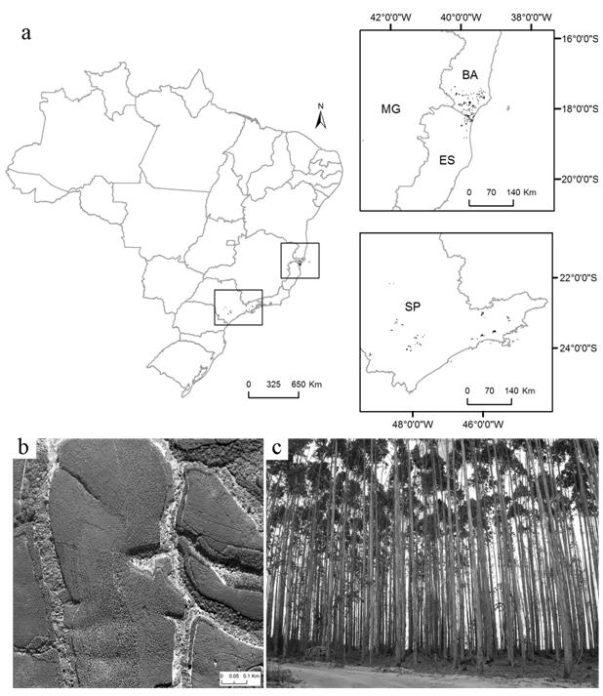

Figure 1 – a) Study site located in two regions of Brazil: northeastern (18º0’0’’S; 40º0’0’’W) and southeastern (23º0’0’’S; 47º0’0’’W) (a). Aerial overview of eucalypt plantation stands (b). Understory view of eucalypt plantation (c).

The input dataset was composed by 6130 eucalypt trees (*Eucalyptus* sp.) with age ranging from 3 to 7 years old, in first and second (coppice) rotations (Table 1) and belonging to 26 genetic families, all of them being clone genotypes. The geographic distribution of the genetic families did not overlap and there were at least 100 trees per genetic family. All sampled trees were log scaled from eucalypt plantations, with mean stem density equal to 1060 stems.ha-1 and varying between 800 and 1300 stems.ha-1 in 95% of stands. Field data collection was carried out in 2006 to 2010.

Table 1 – Summary of log scaled eucalypt trees per region and per groups of age and rotation.

|  |  |  |  |  |  |  |  |  |  |  |  |
| --- | --- | --- | --- | --- | --- | --- | --- | --- | --- | --- | --- |
| Region | BA | | | | |  | SP | | | | |
| Age (year) | n | DBH (cm) | sDBH (cm) | Ht (m) | sHt (m) |  | n | DBH (cm) | sDBH (cm) | Ht (m) | sHt (m) |
| 3 | 295 | 13.0 | 3.5 | 18.2 | 2.9 |  | 256 | 11.9 | 3.3 | 17.9 | 3.1 |
| 4 | 480 | 14.2 | 3.9 | 20.8 | 3.6 |  | 822 | 13.5 | 4.0 | 20.2 | 3.7 |
| 5 | 784 | 15.1 | 4.3 | 22.5 | 4.1 |  | 863 | 14.6 | 4.5 | 22.5 | 4.3 |
| 6 | 791 | 15.5 | 4.5 | 24.0 | 5.0 |  | 889 | 15.9 | 5.2 | 24.3 | 5.3 |
| 7 | 442 | 16.6 | 5.1 | 25.2 | 5.3 |  | 508 | 16.4 | 5.5 | 25.4 | 5.8 |
| Rotation | n | DBH (cm) | sDBH (cm) | Ht (m) | sHt (m) |  | n | DBH (cm) | sDBH (cm) | Ht (m) | sHt (m) |
| 1st | 2622 | 15.1 | 4.4 | 22.6 | 4.8 |  | 2374 | 14.9 | 4.8 | 22.9 | 5.1 |
| 2nd (coppice) | 170 | 14.8 | 4.9 | 22.6 | 5.6 |  | 964 | 14.4 | 5.1 | 21.5 | 5.2 |

n = number of log scaled trees; DBH = diameter at breast height (1.3 m above ground level); sDBH = standard deviation of DBH; Ht = total tree height; sHt = standard deviation of Ht.

Trees were selected from homogeneous strata based on land records and inventory data, with minimum of 6 trees per diameter class, and class width of 2 cm. Log scaling surveys were carried out measuring with calipers over bark diameters along the stem starting from the ground level, and then, at every 1.2 m up to the top, until diameter equal to 3 cm (+/- 2 cm). The log volumes were calculated using the Smalian formula, which assumes the log shape approaching a truncated paraboloid (Cruz de León and Uranga-Valencia, 2013) (Equation 1). The individual stem volume was calculated summing the corresponding log volumes (Equation 2).

$v_{ji}=\frac{\left(B_{j}+ b_{j}\right)* l_{j}}{2}$ (1)

where, $v_{ji}$ = volume of log *j* belonging to tree *i* (m³), $B_{j}$ = cross-sectional area at the large end of log *j* (m²), $b_{j}$ = cross-sectional area at the small end of log *j* (m²), $l$ = log length (m) which was equal among stem sections (1.2 m).

$V_{i}= \sum_{j=1}^{n}{v_{ji}}$ (2)

where,: $V_{i}$ = stem volume of tree *i* (m³); $v_{ji}$ = volume of log *j* belonging to tree *i* (m³).

The Pearson product-moment correlation coefficient (*ρ*) statistic was used to compare the linear relationship between volumes from log sections with individual stem volume (Equation 3). The comparison encompassed logs up to the height of 18 meters, which was the average height of trees in the lowest class of age (Table 1).

${\hat{ρ}}_{j}Vv=\frac{\sum_{i}^{n}{\left(V_{i}-\overline{V}\right)}\left(v_{ji}-{\overline{v}}_{j}\right)}{\sqrt{\sum_{i}^{n}{{\left(V_{i}- \overline{V}\right)}^{2}}}\sqrt{\sum_{i}^{n}{{\left(v_{ji}- {\overline{v}}_{j}\right)}^{2}}}}$ (3)

where, ${\hat{ρ}}_{j}Vv$ = sample Pearson correlation coefficient between stem volume and log volume belonging to class *j*; $V_{i}$ = stem volume of tree *i* (m³); $v_{ji}$ = volume of log *j* belonging to tree *i* (m³); $\overline{V}$ = average of stem volume (m³); ${\overline{v}}_{j}$ = average of log volume in class *j*.

Firstly, the correlation analysis was carried out using all sampled trees, and posterior, we performed a simple random sampling simulation to derive confidence intervals for *ρ*. We also investigated the relationship between DBH and individual stem volume as a reference to compare results obtained from the log volume analysis.

As a secondary task, we took advantage from the large dataset of log scaled trees to study stem form factor (ff) and its variation within trees of different ages and sizes, between first and second rotations and per genetic materials of two regions in Brazil. Additionally, the influence of ff on the correlation between individual volume and log volumes was also investigated. The ff statistic is given in Equation 4.

$ff= \frac{V_{i}}{V_{i cylinder}}$ (4)

where, *ff* = ratio of stem volume and cylindrical volume (stem form factor); $V_{i}$ = stem volume of tree *i* (m³); $V_{i cylinder}$ = cylindrical volume of tree *i* with DBH as the reference diameter and total height as the reference height (m³).

To our knowledge, no study has yet investigated the relationship between individual stem volume and corresponding log volumes in even-aged eucalypt plantations as alternative to conventional relations of stem volume based on DBH, height and stem form.

**Results**

The accumulated stem volume profile showed a quadratic polynomial relationship with relative stem height, where the bottom half was responsible for approximately 76% of total volume (Figure 2).

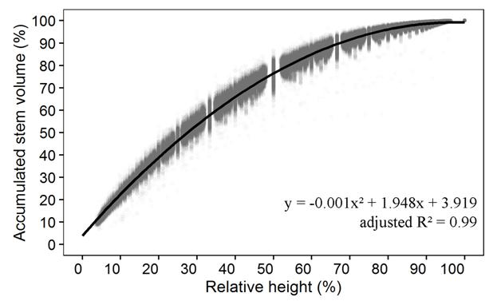

Figure 2 – Accumulated stem volume profile of eucalypt trees.

The correlation between log volume and stem volume was strong in all log sections observed (*ρ* > 0.97). However, the middle layers of the canopy (4.8 m to 14.4 m) presented higher correlation (*ρ* > 0.99) than the base and top layers (Figure 3). The number of observations per log section kept unaltered up to 8.4 m height (n = 6.1 thousand logs). If the same vertical layer was going to be retrieved from a point cloud, it would be desirable to have most of the stems represented within the data.

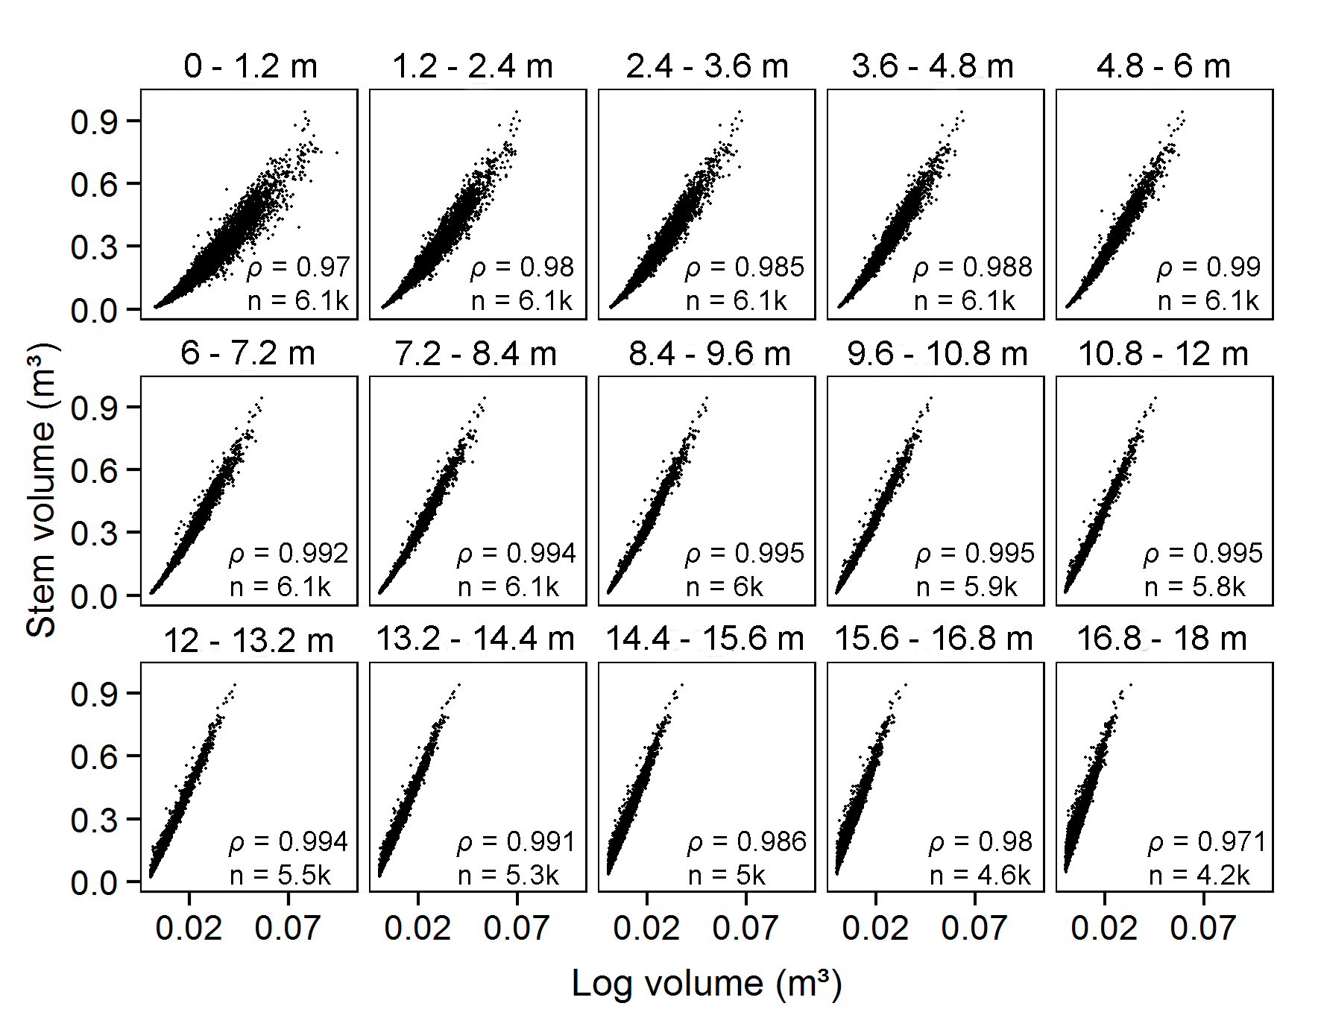

Figure 3 - Scatter plots between stem volume of eucalypt trees and corresponding log volumes per log section. *ρ* = Pearson correlation coefficient; n = sample size; k = thousand.

Up to 99% of all log sections presented ratio between butt and top diameters smaller than 1.5, which is the threshold recommended by the British Columbia Province (2011) for applying the Smalian formula as a scaling rule. On the other hand, the distribution of diameter ratio per log section showed the base log having slightly higher diameter ratio than adjacent logs in the stem (Figure 4).

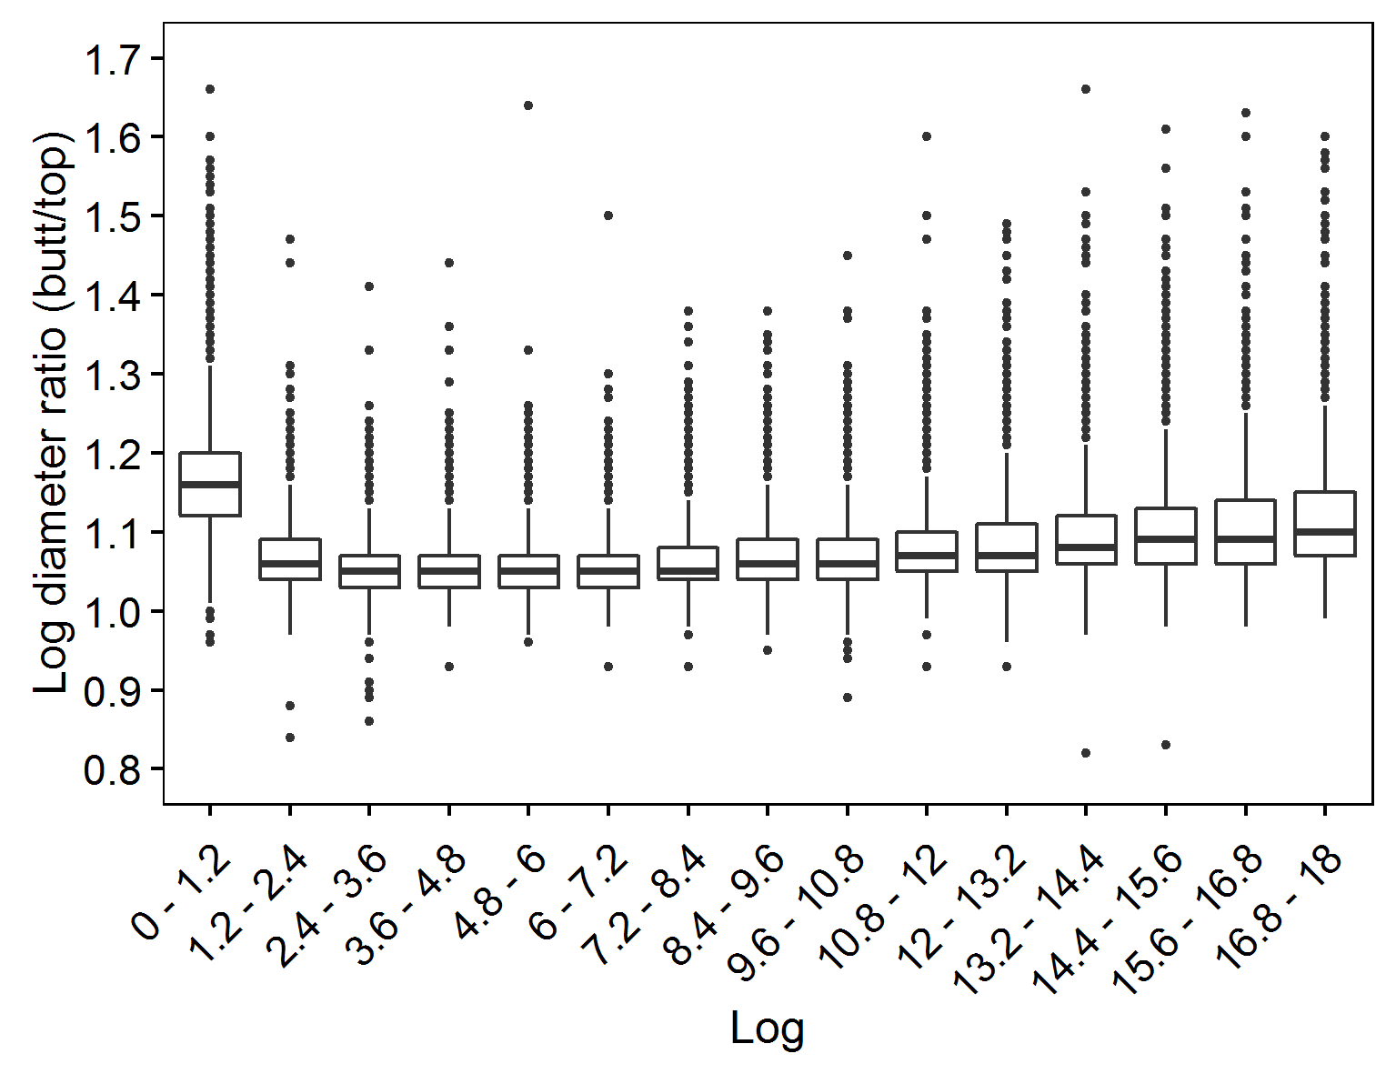

Figure 4 – Log diameter ratio (butt/top) per log section of eucalypt trees.

As expected, DBH did not correlate with stem volume as well as the log sections (*ρ* < 0.96) mainly due to absence of linear relation with stem volume. Best correlation results were achieved transforming both variables with the natural logarithm (*ρ* = 0.99; Figure 5). Despite using transformed DBH has increased correlation up to the same level of log sections from the middle canopy, it is simpler working with untransformed variables.

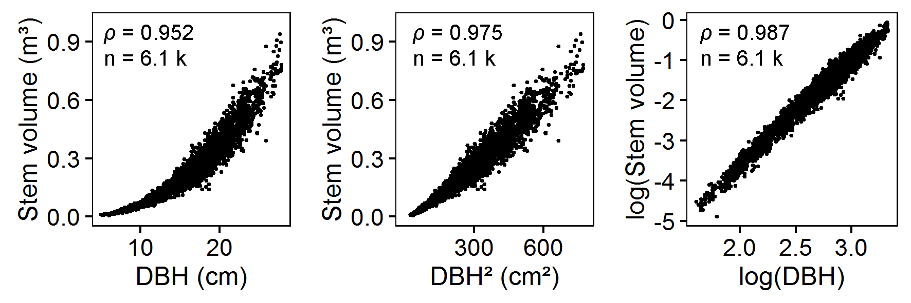

Figure 5 - Scatter plots between stem volume of eucalypt trees and DBH. *ρ* = Pearson correlation coefficient; n = sample size; k = thousand.

The random sampling simulation showed narrower confidence intervals for *ρ* in log sections belonging to the middle canopy, indicating increased precision in the statistic for such sections (Figure 6).

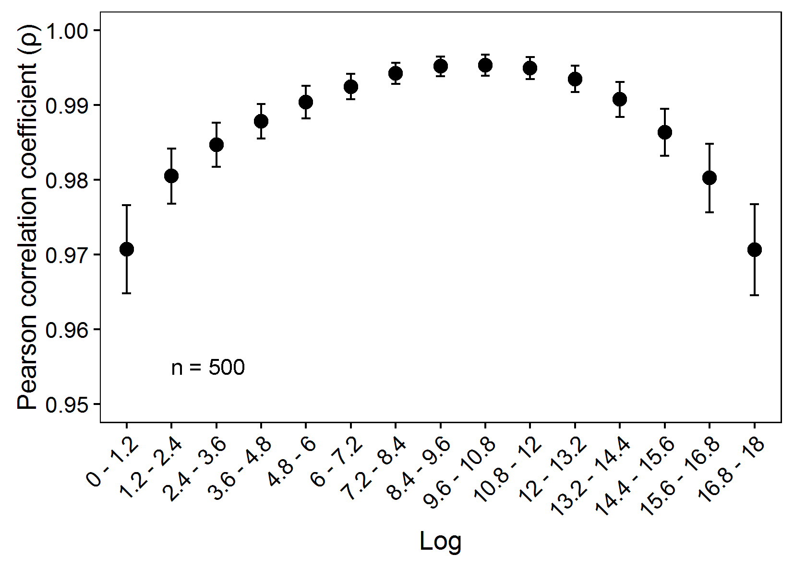

Figure 6 - Pearson correlation coefficient (*ρ*) between individual stem volume and log sections of eucalypt trees derived from averaging the statistic after 1000 simulations of simple random sampling. The vertical bars indicate the confidence intervals for *ρ* (95% confidence level) and n is the sample size used per simulation.

The mean value observed for the ff statistic was 0.44 with a standard deviation equal to 0.04.The visual analysis of ff distributions per groups of age showed no clear pattern of variation. A small difference was observed between first and second rotations, being the former the one with highest median. On the other hand, higher differences of ff were observed in trees belonging to different locations and from different genetic materials. In fact, the box plot ranked all clones from BA region as having the highest medians (Figure 7).

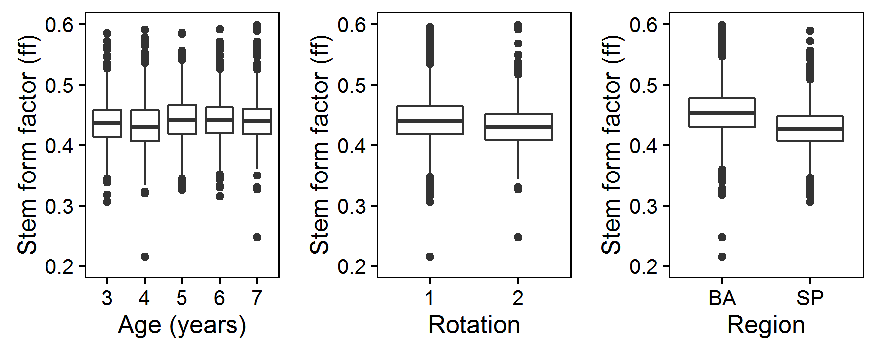

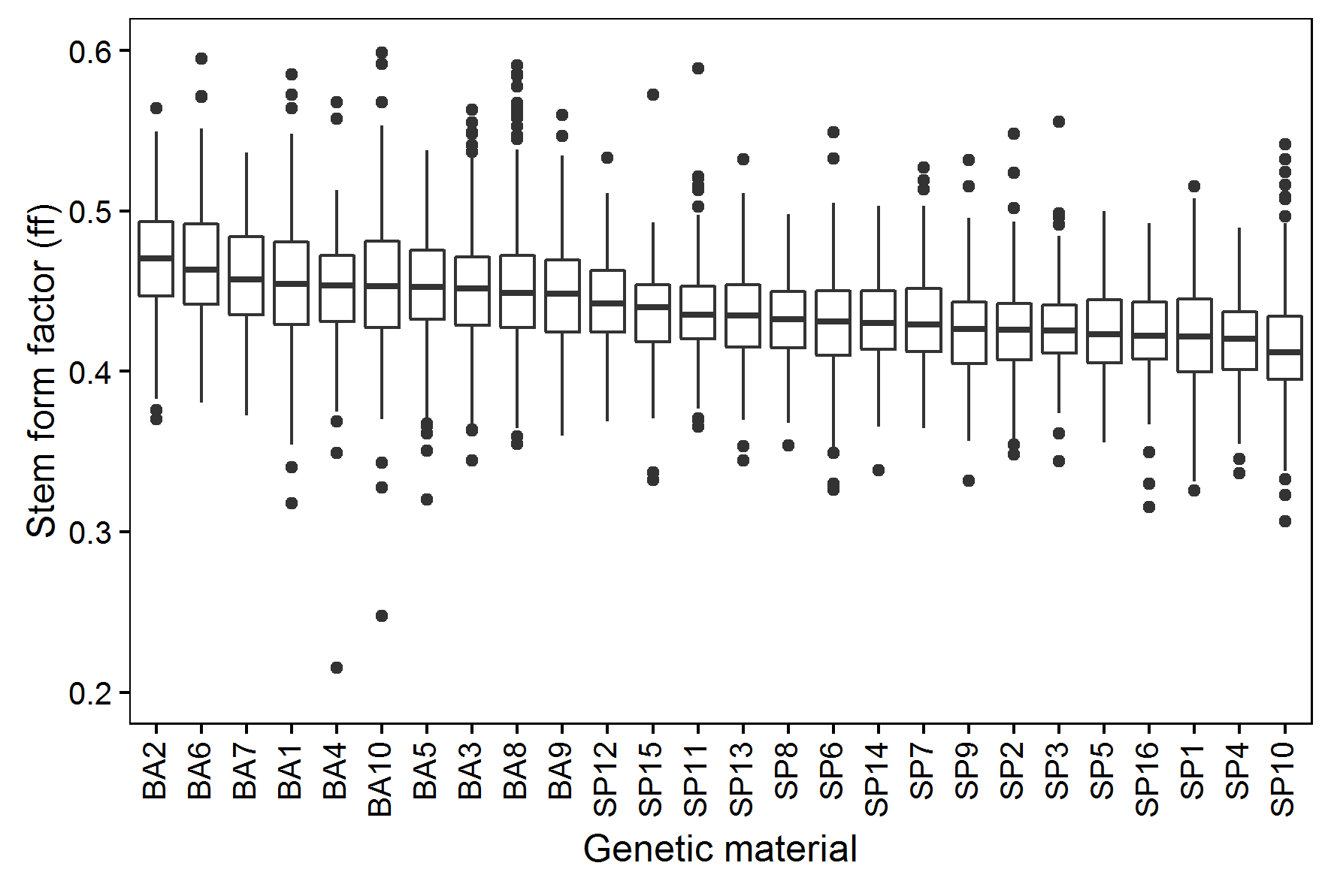

Figure 7 – Stem form factor (ff) distribution of log scaled eucalypt trees per classes of tree age, rotation, geographic region and genetic material.

The main correlation pattern between stem volume and log volumes when analyzed within groups of regions kept unaltered. An observation was that trees belonging to SP region showed higher correlation for all log sections, especially at the base log where confidence intervals for *ρ* did not overlap with the ones from BA region (Figure 8).

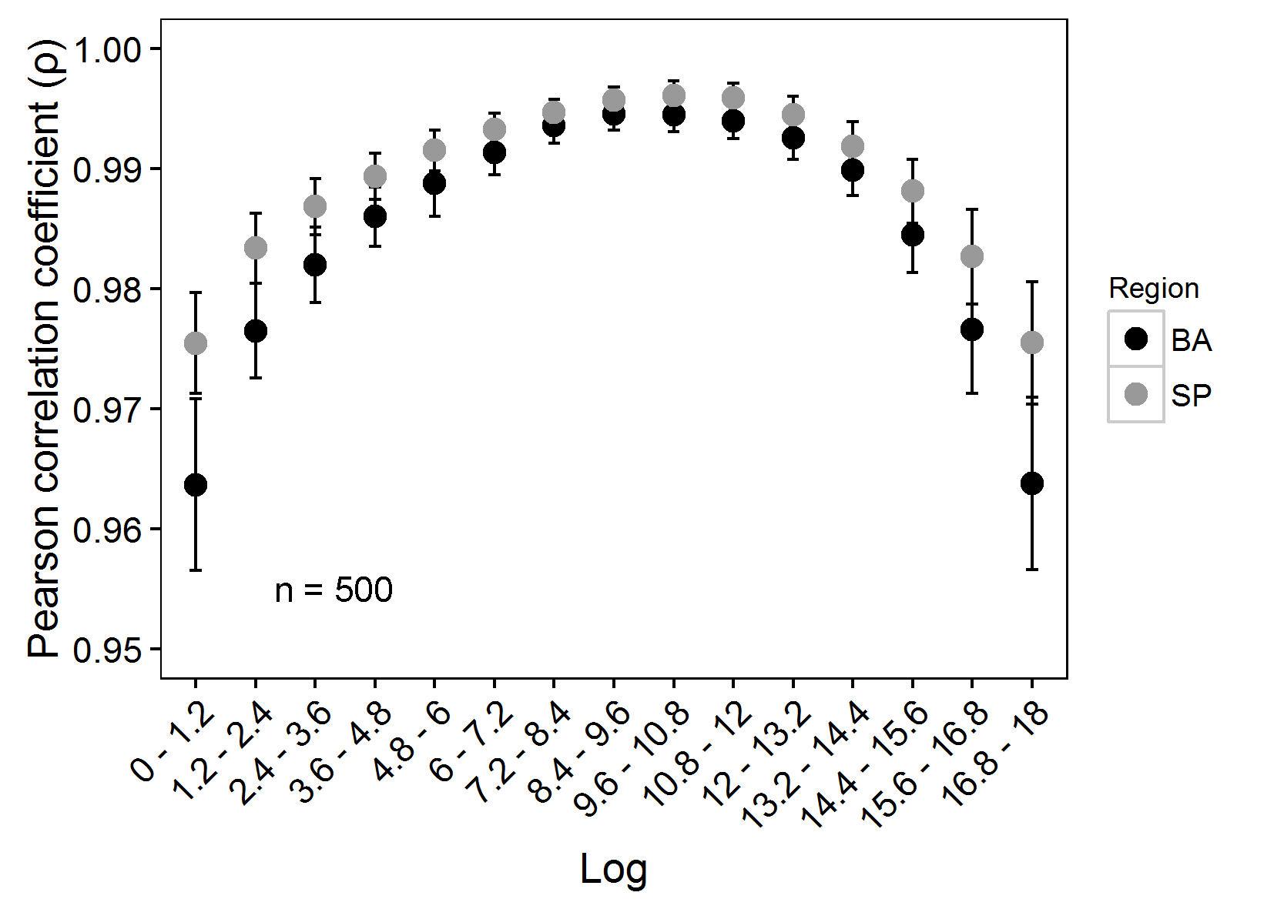

Figure 8 - Pearson correlation coefficient (*ρ*) between individual stem volume and log sections of eucalypt trees per region, derived from averaging the statistic after 1000 simulations of simple random sampling. The vertical bars indicate the confidence intervals for *ρ* (95% confidence level). BA = Bahia state; SP = São Paulo state; n = sample size per simulation.

Although we had observed the ff statistic did not vary across ages, when analyzing it per groups of stem size, trees with DBH greater than the 66th percentile showed a slight increasing tendency. On the other hand, they presented lower ff values than medium and small-sized trees within groups of age (Table 2).

Table 2 – Mean values of stem form factor (ff) within groups of trees based on DBH size: <33th percentile, 33th to 66th percentile and >66th percentile, per age and region (BA and SP).

|  |  |  |  |  |  |  |  |  |  |  |
| --- | --- | --- | --- | --- | --- | --- | --- | --- | --- | --- |
| Mean values of ff per group of trees based on DBH size | | | | | | | | | | |
| Age (year) |  | BA | | | |  | SP | | | |
|  | <33th | 33th-66th | >66th | all |  | <33th | 33th-66th | >66th | all |
| 3 |  | 0.47 | 0.45 | 0.42 | 0.45 |  | 0.44 | 0.43 | 0.41 | 0.43 |
| 4 |  | 0.47 | 0.46 | 0.43 | 0.45 |  | 0.43 | 0.43 | 0.41 | 0.42 |
| 5 |  | 0.47 | 0.46 | 0.44 | 0.46 |  | 0.43 | 0.43 | 0.42 | 0.43 |
| 6 |  | 0.46 | 0.46 | 0.44 | 0.45 |  | 0.44 | 0.44 | 0.42 | 0.43 |
| 7 |  | 0.46 | 0.45 | 0.44 | 0.45 |  | 0.43 | 0.43 | 0.43 | 0.43 |

When investigating the correlation between individual stem volume and log volume per groups of stem size, it was possible to see that stems with DBH smaller than the 33th percentile had narrower optimum range for *ρ*, and also reached maximum correlation in lower logs than the other groups. If a specific vertical layer of the canopy was going to be selected for modeling individual stem volume, more weight would be given to biggest trees due to their greater amount of volume; for example, trees from DBH group >66th (which represent 1/3 of all trees) had 57.7% and 60% of total volume in BA and SP, respectively. Nonetheless, it was possible to observe intersections between groups of tree size to maximize correlation (logs 8.4 - 9.6 m and 9.6 - 10.8 m, Figure 9).

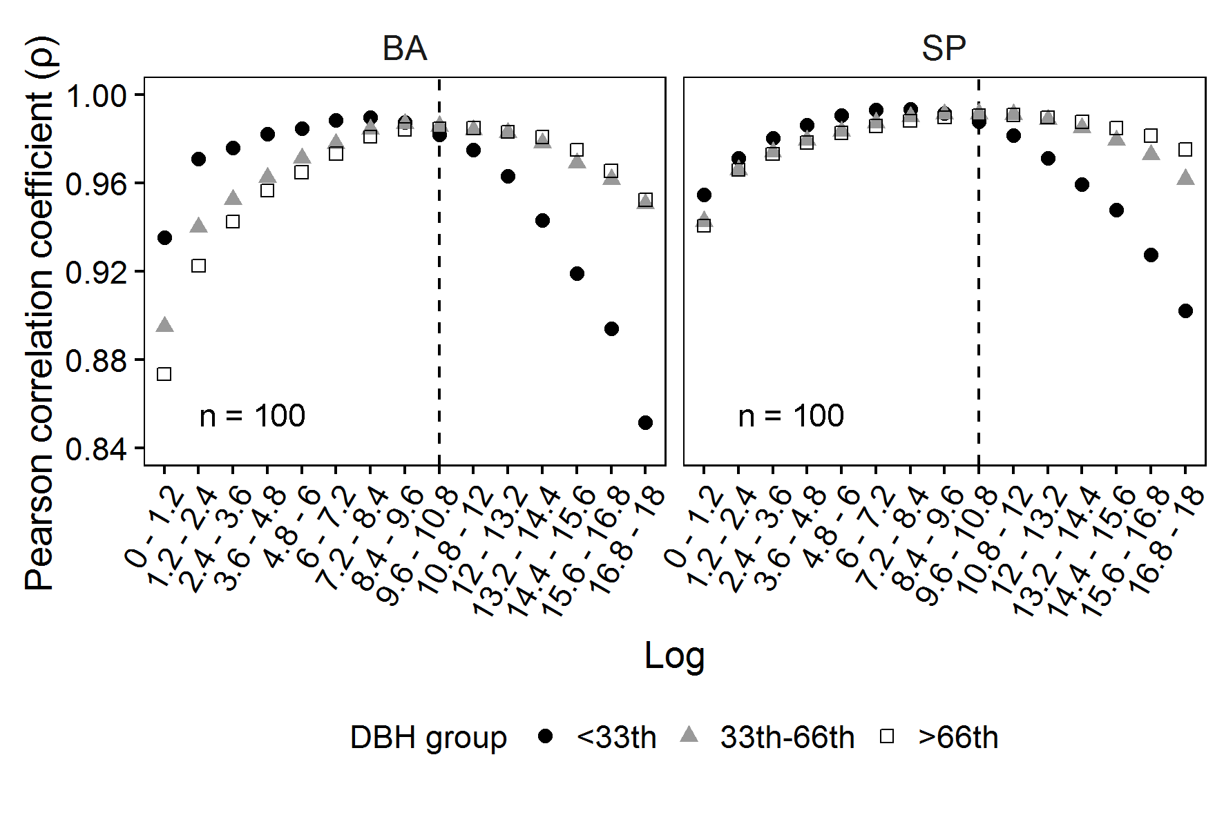

Figure 9 - Pearson correlation coefficient (*ρ*) between individual stem volume and log sections of eucalypt trees, per region and per groups of DBH size, derived from averaging the statistic after 1000 simulations of simple random sampling. BA = Bahia state; SP = São Paulo state; n = sample size per simulation; DBH groups = trees with DBH smaller than the 33th percentile, between 33th and 66th percentiles, and greater than the 66th percentile.

**Discussion**

The base log showed the least linear correlation with individual stem volume when compared to other sections along the stem. A partial explanation relies on the Smalian formula not capturing the log volume with the same accuracy as the other sections. The greater observed ratio between butt and top diameters in the base log suggests better results for volume calculation could be achieved by bucking the log into minor sections or measuring it according to another scaling rule such as Huber (Cruz de León and Uranga-Valencia, 2013). This is because lower parts of the stem approximate to geometric form of truncated neiloid, in which the Smalian formula overestimates the volume (Cruz de León and Uranga-Valencia, 2013; van Laar and Akça, 2007; British Columbia Province, 2011). Moreover, the neiloid shape in the base of a tree is potentiated due to the log scaling method having the initial diameter being measured at the ground level where small buttresses can occur, instead of starting measuring at the stump height (Liang et al., 2014).

Best correlation results between log volume and individual stem volume were observed for sections belonging to the middle layers of the canopy, regardless of region, age and size of eucalypt trees. This is a promising result, because when using absolute values of height it is possible to select a specific layer of the canopy to work with, while with relative heights it would be necessary to measure diameters and volumes in different parts of the stem among trees. In the context of remotely assessing eucalypt plantations with point cloud data, such results are promising because middle parts of the stem have been reported as being measured with the most accuracy and readiness. For example, Surový et al. (2016) used computer vision and photogrammetry to reconstruct tree stem surfaces in mixed evergreen broad-leaved trees in Japan, and they observed most of measurement errors were concentrated in bottom and upper parts of the stem where visibility was lower. Murphy et al. (2010) compared diameter measurements of *Pinus radiata* (D. Don) plantations in Australia, between TLS data and field measurements of harvested trees. They observed greater bias (underestimation) of the TLS data in logs belonging to both the base (up to 1.5 m) and in the upper layers (greater than 22 m). Additionally, the authors observed that larger bias in the base log were related to forked trees below the DBH. Similarly, Henning and Radtke (2006) used TLS data to retrieve diameters along the stem from a 20-year-old *Pinus taeda* L. plantation in United States of America. They found that average errors between TLS and caliper measurements were greater in the base log and also increased with heights above 10 m.

Kankare et al (2014) studying timber quality in mature trees of *Pinus sylvestris* L. in Finland showed that the shadowing effect on the TLS-point cloud due to understory vegetation caused errors when measuring heights to lowest live and dead branches. Moreover, Liang et al. (2014) succeeded to automatically retrieve stem curves from trees of *Pinus sylvestris* L. and *Picea abies* L with TLS data, but they were able to only measure diameters up to the relative heights of 65.8% and 61%, respectively. Even when the top of the stem is not occluded, it is easier to classify and isolate laser points of middle canopy because the target surface is wider, hence, the number of laser points recorded is also greater (Henning and Radtke, 2006; Liang et al., 2014). One specific advantage is that intermediate heights along a eucalypt stem have proportionally lesser amount of bark when compared to the extremes parts of it (Oliveira et al., 1999).

Regarding the ff statistic, it was mainly influenced by genetic material and region, besides stem size; the latter being consistent with previous literature (Almeida et al., 2011). Nevertheless, it was possible to select vertical layers in the canopy where correlation between individual stem volume and log volumes was near optimal, independent of tree type.

**Conclusions**

In eucalypt even-aged plantations, log volumes belonging to the middle canopy were as good predictors of individual stem volume as transformed DBHs. In the context of inventorying with terrestrial laser scanning or with stereoscope images, such results are promising, because middle layers of the canopy are less prone to obstruction and measurement errors.

**Acknowledgments**

This paper is part of the research program developed by GET-LiDAR (http://cmq.esalq.usp.br/getlidar/doku.php). We acknowledge the institution Suzano Pulp and Paper for its support in providing the field dataset.

**References**

Almeida, R. C. de, Cabacinha, C. D., Rocha, T. B., & Paula, A. de. (2011). Volumetry of Eucalyptus urophylla S.T. Blake for the geometric method in Planalto da Conquista, Brazil. *Revista Caatinga*, *24*(1), 65–75. (In Portuguese, abstract in English).

Aschoff, T., & Spiecker, H. (2004). Algorithms for the automatic detection of trees in laser scanner data. *International Archives of the Photogrammetry, Remote Sensing and Spatial Information Sciences* (Vol. XXXVI–8/W2, pp. 71–75). ISPRS.

Astrup, R., Ducey, M. J., Granhus, A., Ritter, T., & von Lüpke, N. (2014). Approaches for estimating stand-level volume using terrestrial laser scanning in a single-scan mode. *Canadian Journal of Forest Research*, *44*(6), 666–676. doi:10.1139/cjfr-2013-0535

Baltsavias, E. P. (1999). Airborne laser scanning: basic relations and formulas. *ISPRS Journal of Photogrammetry and Remote Sensing*, *54*(2-3), 199–214. doi:10.1016/S0924-2716(99)00015-5

Batista, J. L. F., Couto, H. T. Z.; Silva Filho, D. F. (2014). *Quantificação de recursos florestais - árvores, arvoredos e florestas* (1st ed.). Piracicaba-SP, Brazil: Oficina de textos.(in Portuguese).

Binkley, D., Stape, J. L., Ryan, M. G., Barnard, H. R., & Fownes, J. (2002). Age-related decline in forest ecosystem growth: An individual-tree, stand-structure hypothesis. *Ecosystems*, *5*(1), 58–67. doi:10.1007/s10021-001-0055-7

British Columbia Province (2011). Scaling Manual. Timber Pricing Branch; Ministry of Forests, Lands and Natural Resource Operations. Victoria, BC, Canada. Acessed from: http://www2.gov.bc.ca/gov/content/industry/forestry/competitive-forest-industry/timber-pricing/timber-scaling/timber-scaling-manual

Campos, J. C. C., & Leite, H. G. (2013). *Mensuracão Florestal - perguntas e respostas* (4a ed.). Viçosa, MG, Brazil, Brazil: Editora UFV. (in Portuguese).

Cheng, Z.-L., Zhang, X.-P., & Chen, B.-Q. (2007). Simple Reconstruction of Tree Branches from a Single Range Image. *Journal of Computer Science and Technology*, *22*(6), 846–858. doi:10.1007/s11390-007-9095-6

Cruz de León, G., & Uranga-Valencia, L. P. (2013). Theoretical evaluation of Huber and Smalian methods applied to tree stem classical geometries. *Bosque (Valdivia)*, *34*(3), 13–14. doi:10.4067/S0717-92002013000300007

Dassot, M., Constant, T., & Fournier, M. (2011). The use of terrestrial LiDAR technology in forest science: Application fields, benefits and challenges. *Annals of Forest Science*, *68*(5), 959–974. doi:10.1007/s13595-011-0102-2

Diaz-Balteiro, L., Bertomeu, M., & Bertomeu, M. (2009). Optimal harvest scheduling in Eucalyptus plantations. A case study in Galicia (Spain). *Forest Policy and Economics*, *11*(8), 548–554. doi:10.1016/j.forpol.2009.07.005

Forsman, M., Börlin, N., & Holmgren, J. (2016). Estimation of Tree Stem Attributes Using Terrestrial Photogrammetry with a Camera Rig. *Forests*, *61*(7), 1–20. doi:10.3390/f7030061

Gonçalves, J. L. D. M., Alvares, C. A., Higa, A. R., Silva, L. D., Alfenas, A. C., Stahl, J., … Epron, D. (2013). Integrating genetic and silvicultural strategies to minimize abiotic and biotic constraints in Brazilian eucalypt plantations. *Forest Ecology and Management*, *301*, 6–27. doi:10.1016/j.foreco.2012.12.030

Görgens, E. B., Packalen, P., da Silva, A. G. P., Alvares, C. A., Campoe, O. C., Stape, J. L., & Rodriguez, L. C. E. (2015). Stand volume models based on stable metrics as from multiple ALS acquisitions in Eucalyptus plantations. *Annals of Forest Science*, *72*(4), 489–498. doi:10.1007/s13595-015-0457-x

IBGE (2015). Aggregated Database (SIDRA). Accessed from: http://www.sidra.ibge.gov.br/bda/acervo/acervo9.asp?e=c&p=VS&z=t&o=29

Henning, J. G., & Radtke, P. J. (2006). Detailed stem measurements of standing trees from ground-based scanning lidar. *Forest Science*, *52*(1), 67–80. Retrieved from http://www.ingentaconnect.com/content/saf/fs/2006/00000052/00000001/art00007#expand/collapse

Hopkinson, C., Chasmer, L., Young-Pow, C., & Treitz, P. (2004). Assessing forest metrics with a ground-based scanning lidar. *Canadian Journal of Forest Research*, *34*(3), 573–583. doi:10.1139/x03-225

Kankare, V., Joensuu, M., Vauhkonen, J., Holopainen, M., Tanhuanpää, T., Vastaranta, M., … Sipi, M. (2014). Estimation of the Timber Quality of Scots Pine with Terrestrial Laser Scanning. *Forests*, *5*(8), 1879–1895. doi:10.3390/f5081879

Ketterings, Q. M., Coe, R., Van Noordwijk, M., Ambagau, Y., & Palm, C. A. (2001). Reducing uncertain in the use of allometric biomass equation for predciting above-ground tree biomass in mixed secondary forests. *Forest Ecology and Management*, *146*, 199–209.

Liang, X., Kankare, V., Hyyppä, J., Wang, Y., Kukko, A., Haggrén, H., … Vastaranta, M. (2016). Terrestrial laser scanning in forest inventories. *ISPRS Journal of Photogrammetry and Remote Sensing*. doi:10.1016/j.isprsjprs.2016.01.006

Liang, X., Kankare, V., Xiaowei, Y., Hyyppa, J., & Holopainen, M. (2014). Automated Stem Curve Measurement Using Terrestrial Laser Scanning. *IEEE Transactions on Geoscience and Remote Sensing*, *52*(3), 1739–1748. doi:10.1109/TGRS.2013.2253783

Lefsky, M., & McHale, M. R. (2008). Volume estimates of trees with complex architecture from terrestrial laser scanning. *Journal of Applied Remote Sensing*, *2*(1), 023521. doi:10.1117/1.2939008

Maas, H. G., Bienert, A., Scheller, S., Keane, E., Bienert, A., Scheller, S., & Automatic, E. K. (2008). Automatic forest inventory parameter determination from terrestrial laser scanner data, *29*(5), 1579–1593. doi:10.1080/01431160701736406

McDill, M. E., Tóth, S. F., St. John, R., Braze, J., & Rebain, S. A. (2016). Comparing model I and model II formulations of spatially explicit harvest scheduling models with maximum area restrictions. *Forest Science*, *62*(1), 28–37. doi:10.5849/forsci.14-179

Moskal, L. M., & Zheng, G. (2012). Retrieving forest inventory variables with terrestrial laser scanning (TLS) in urban heterogeneous forest. *Remote Sensing*, *4*(1), 1–20. doi:10.3390/rs4010001

Murphy, G. E., Acuna, M. a., & Dumbrell, I. (2010). Tree value and log product yield determination in radiata pine ( Pinus radiata ) plantations in Australia: comparisons of terrestrial laser scanning with a forest inventory system and manual measurements. *Canadian Journal of Forest Research*, *40*(11), 2223–2233. doi:10.1139/X10-171

Oliveira, J. T. da S., Hellmeister, J. C., Simões, J. W., & Filho, M. T. (1999). Characterization of seven eucalypt wood species to civil construction : 1- dendrometrics evaluations of the trees. Scientia Forestalis, *56*, 113–124. Retrieved from http://www.ipef.br/publicacoes/scientia/nr56.asp. (In Portuguese, abstract in English).

Patenaude, G., Milne, R., & Dawson, T. P. (2005). Synthesis of remote sensing approaches for forest carbon estimation: reporting to the Kyoto Protocol. *Environmental Science and Policy*, *8*(2), 161–178. doi:10.1016/j.envsci.2004.12.010

Payn, T., Carnus, J. M., Freer-Smith, P., Kimberley, M., Kollert, W., Liu, S., … Wingfield, M. J. (2015). Changes in planted forests and future global implications. *Forest Ecology and Management*, *352*, 57–67. doi:10.1016/j.foreco.2015.06.021

Pommerening, A. (2002). Approaches to quantifying forest structures. *Forestry*, *75*(3), 305–324. doi:10.1093/forestry/75.3.305

Rode, R., Leite, H. G., Silva, M. L. da, Ribeiro, C. A. Á. S., & Binoti, D. H. B. (2014). The economics and optimal management regimes of eucalyptus plantations: A case study of forestry outgrower schemes in Brazil. *Forest Policy and Economics*, *44*, 26–33. doi:10.1016/j.forpol.2014.05.001

Schumacher, F. X., & Hall, F. dos S. (1933). Logarithmic expression of timber-tree volume. *Journal of Agriculture Research*, *47*(9), 719–734. Retrieved from http://naldc.nal.usda.gov/download/IND43968352/PDF

Silva, A. G. P., Görgens, E. B., Campoe, O. C., Alvares, C. A., Stape, J. L., & Rodriguez, L. C. E. (2015). Assessing biomass based on canopy height profiles using airborne laser scanning data in eucalypt plantations. *Scientia Agricola*, *72*(6), 504–512. doi:10.1590/0103-9016-2015-0070

Silva, C. A., Klauberg, C., Carvalho, S. de P. C., Hudak, A. T., & Rodriguez, L. C. E. (2014). Mapping aboveground carbon stocks using LiDAR data in Eucalyptus spp. plantations in the state of São Paulo, Brazil. *Scientia Forestalis*, *42*(104).

Surový, P., Yoshimoto, A., & Panagiotidis, D. (2016). Accuracy of Reconstruction of the Tree Stem Surface Using Terrestrial Close-Range Photogrammetry. *Remote Sensing*, *123*(8), 1–13. doi:10.3390/rs8020123

Tansey, K., Selmes, N., Anstee, A., Tate, N. J., & Denniss, A. (2009). Estimating tree and stand variables in a Corsican Pine woodland from terrestrial laser scanner data. *International Journal of Remote Sensing*, *30*(19), 5195–5209. doi:10.1080/01431160902882587

Thies, M., Pfeifer, N., Winterhalder, D., & Gorte, B. G. H. (2004). Three-dimensional reconstruction of stems for assessment of taper, sweep and lean based on laser scanning of standing trees. *Scandinavian Journal of Forest Research*, *19*(January 2014), 571–581. doi:10.1080/02827580410019562

van Laar, A., & Akça, A. (2007). *Forest Mensuration* (2nd ed., Vol. 13). Dordrecht: Springer Netherlands. doi:10.1007/978-1-4020-5991-9

Watt, P. J., & Donoghue, D. N. M. (2005). Measuring Forest Structure with Terrestrial Laser Scanning. *Int J Remote Sens*, *26*(7), 1437–1446. doi:10.1080/01431160512331337961

Zhou, J., Proisy, C., Descombes, X., le Maire, G., Nouvellon, Y., Stape, J.-L., … Couteron, P. (2013). Mapping local density of young Eucalyptus plantations by individual tree detection in high spatial resolution satellite images. *Forest Ecology and Management*, *301*, 129–141. doi:10.1016/j.foreco.2012.10.007